Software Requirements Specification

Educational Quiz Game Framework

Revision 2

January 19, 2016

*Prepared for:*

School District 73

Dufferin Elementary

*Prepared by:*

Steven Lyall and Greg Petersen

Department of Computing Science

Thompson Rivers University

Supervisor: Dr. Musfiq Rahman

# **Purpose**

This document provides a high level overview of the solution for managing and delivering instructor-defined quizzes as games to be completed by students on iPads. It is intended to describe the intended functionality desired by the client as well as an overview of the intended system architecture.

## Revision History

|  |  |  |  |
| --- | --- | --- | --- |
| **Revision #** | **Date** | **Description** | **Revision by** |
| 1 | 12/18/2015 | First draft | SL/GP |
| 2 | 1/19/2016 | Update architecture diagram | SL |
| 3 | 1/27/2016 | Update following weekly meeting | SL |
| 4 | 2/2/2016 | Update data model | DL |
|  |  |  |  |

# **Introduction**

The system is intended to allow instructors (and later, authorized students) to create quiz questions and quizzes that can be played through by students on tablet devices. The quizzes and quiz content will be created and customized by the instructor through a web interface, where she/he can create quizzes with modules of questions and later retrieve student result data.

Students will complete a quiz on a mobile device, represented by a game. At specific checkpoints, they will need to complete a module of questions in order to progress through the game. After completing the game/quiz, their results will be made available for the instructor.

The deliverable for the current project is to produce a web application and web service which allow instructors to customize, deliver and review quizzes, and a mobile-first responsive web application for students which can retrieve quizzes, demonstrate a basic game, and send the results to the web service to be retrieved using the web application.

Using this modular structure, the mobile web application for students can be replaced with a more complex native mobile application utilizing the web service with minimal modification.

# **Functional Requirements**

#### Use Cases



**Non-Functional Requirements**

* The student game component must be accessible from a mobile device.
* If/when sound is used in the student game component, there should be an option to mute any sounds.
* Student progress in the game should be saved, and students should be able to return later to pick up where they left off.
* Student high scores should be visible to other students.
* The student game should ensure that perceived performance of the application is acceptable, and users are not left waiting for more than a moment when necessary.
* The system must not subject users to advertisements for services other than the application.
* The student game must not limit a student’s progression based on their membership or subscription status.

### To be Considered/Future[1]

* The student game component should strive to avoid resembling/suggesting structured school-based learning.
* It should be possible to play the student game component without an internet connection.
* The student game should allow for a non-linear progression, with differing, divergent paths to follow.
* The student game should provide hints for students having difficulty.
* The student game should allow for a degree of character progression, leveling up as the student progresses through the game.
* The student game should allow students to create and customize an avatar and obtain reward items for it by completing tasks in the game.
* The student game should allow students to interact with and compete with other students.
* The application should record statistics on question responses to be displayed in reporting, including time spent to answer each question, number of attempts, and whether or not the attempts were correct,

**Physical View**



**Logical View**

#### Entity Relationship Diagram – Conceptual Data Model

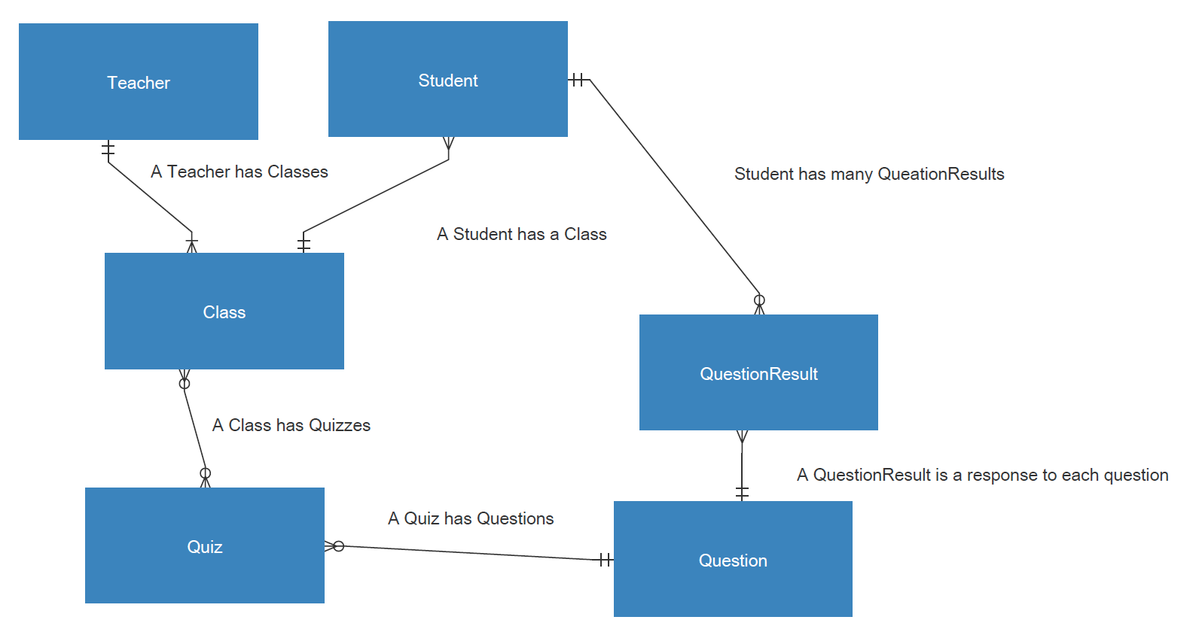

#### Physical Data Model – MySQL implementation with Sequelize.js wrapper

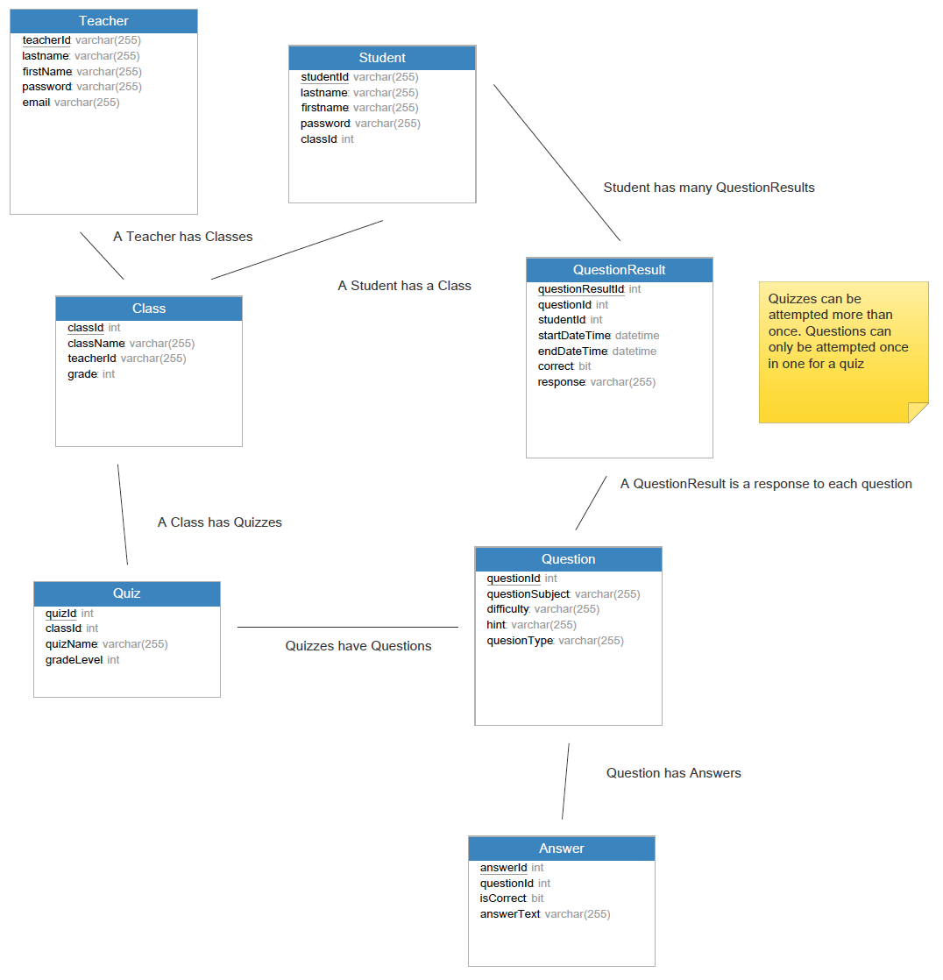

# **Development View**

The agile development process we have chosen will have its sprints, tasks and progress outlined in our YouTrack InCloud issue tracking tool, located at <http://kidsapp.myjetbrains.com/youtrack/projects>, and will not be discussed in this document to ensure that our documentation remains maintainable.

1. Desirable characteristics of a future game identified by grade 6-7 students in class discussions on Janurary 15, 2016